**Online Pharmacy Management System**

**Shairal Neema**

**801053060**

**Table of Contents**

|  |  |  |
| --- | --- | --- |
| S.no. | Contents | Page no. |
|  | Project Overview | 3 |
|  | Types of Users | 4 |
|  | Screenshots | 5 |

**Project Name:** **Online Pharmacy Management System**

**Project Overview:**

Online Pharmacy Management System is a web application which focuses on maintaining a pharmacy online. The project has two types of users- Admin and Sales person. Admin can add, medicines, add vendors and read the stock available and Sales person can sale and purchase medicines. Both the users need to login to access the application and can sign-out at any given point of time. This application is designed to help in maintain the pharmacy online and effectively.

**Types of User and User Privileges:**

Below are the types of users for the web application:

1. Admin:
   1. Admin can add Sales person.
   2. Admin can add medicines.
   3. Admin can add vendors.
   4. Admin can view the stock.
2. Sales Person:
   1. Sales person can login with the credentials approved by admin. The user gets an email of approval by admin as soon as the admin adds them as a sales person.
   2. Sales person can add sales bill.
   3. Sales person can add purchase bills.

**Screenshots:**

1. This is the screen user gets to see at first.

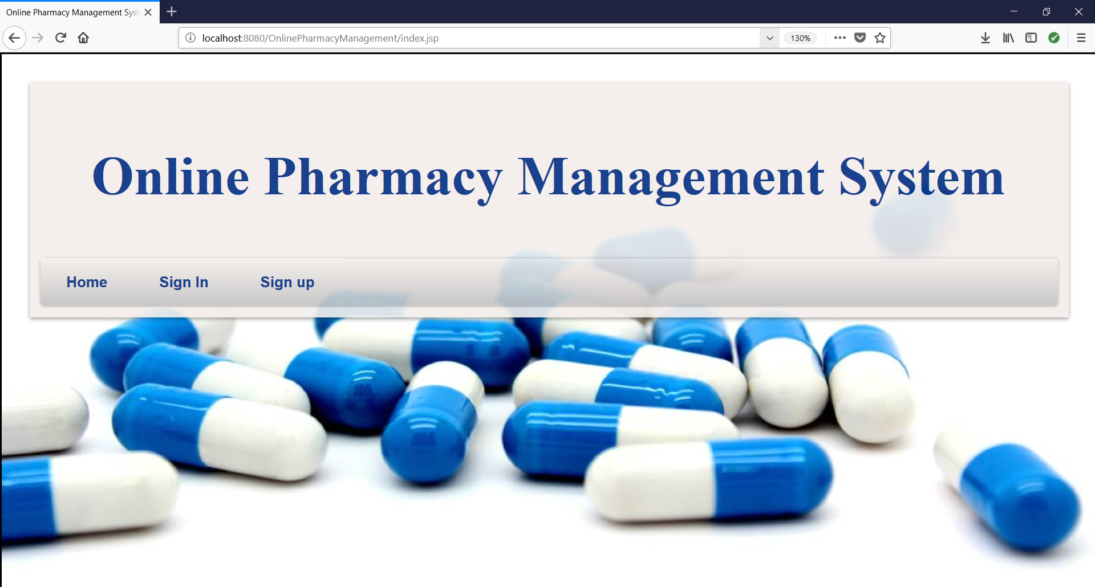

1. The user then has to either sign in or sign up

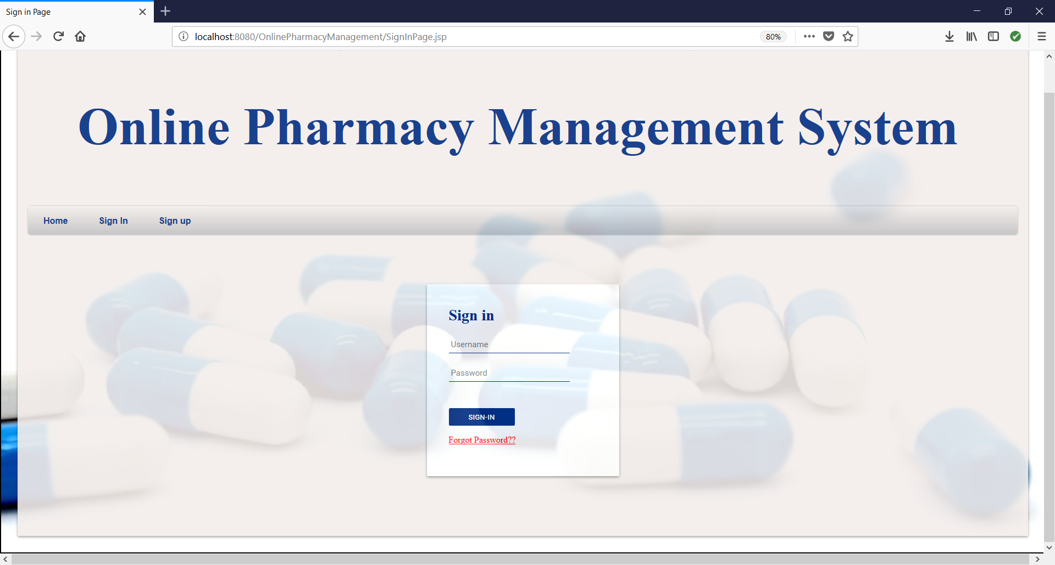

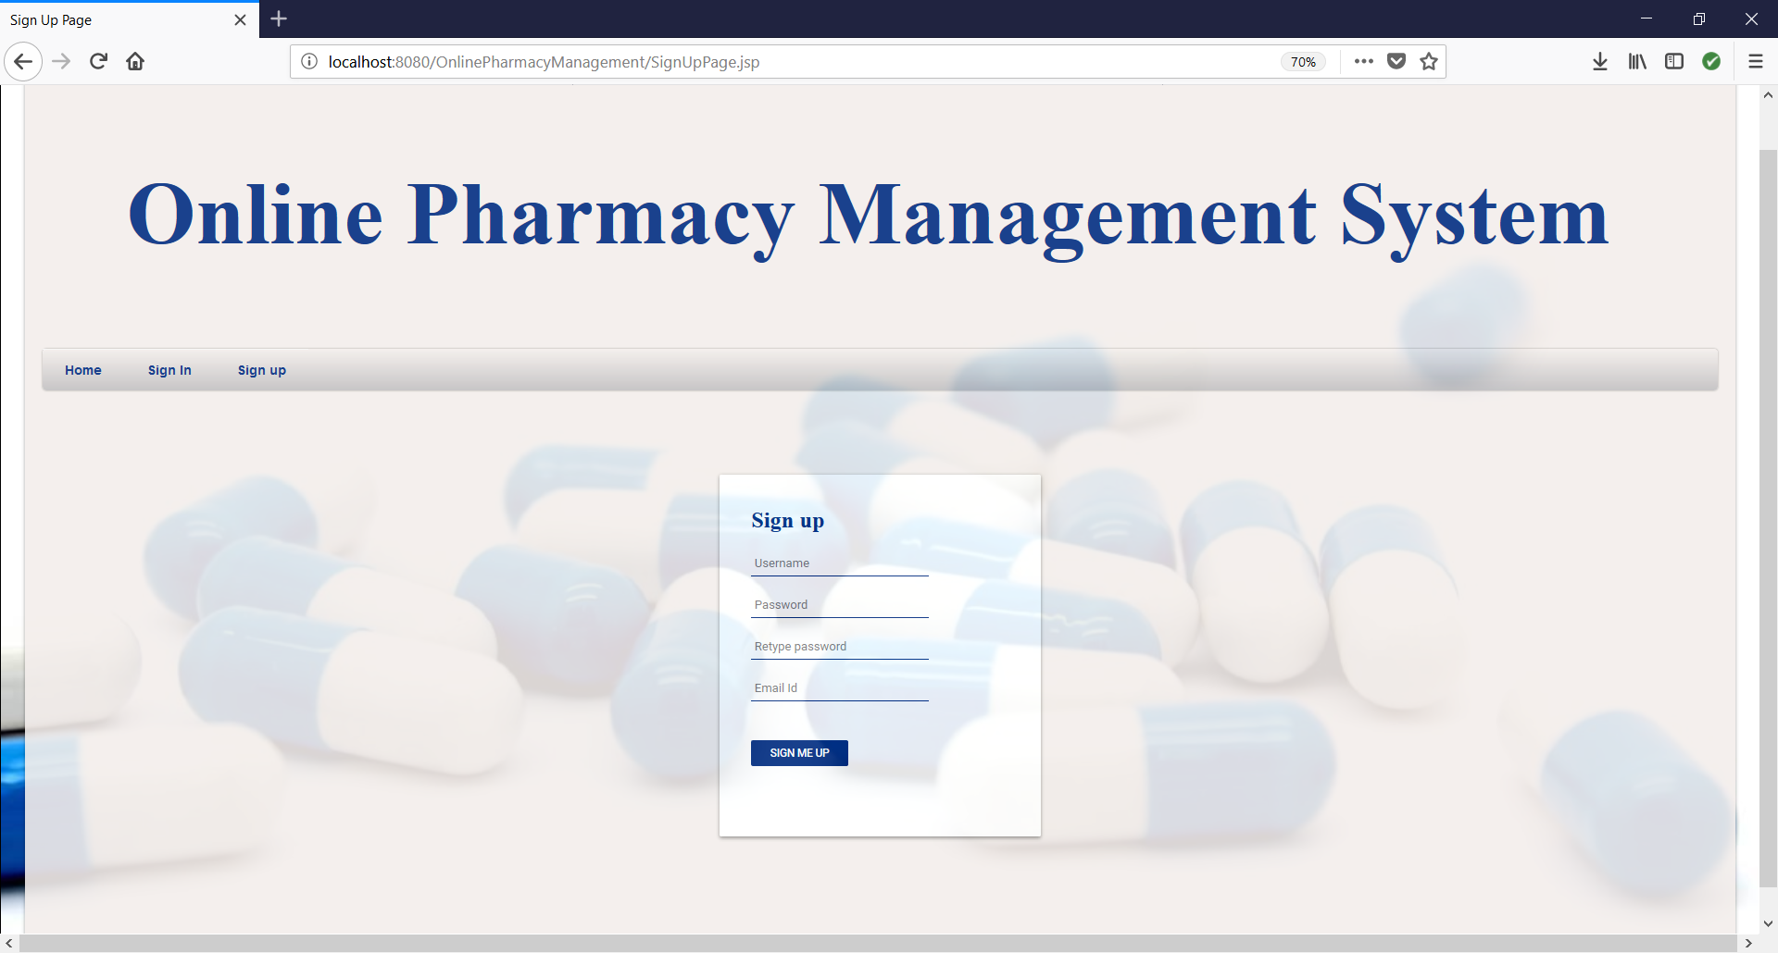

1. After this depending on the user privilege the user gets to proceed to the screens below.
   1. Sales person:

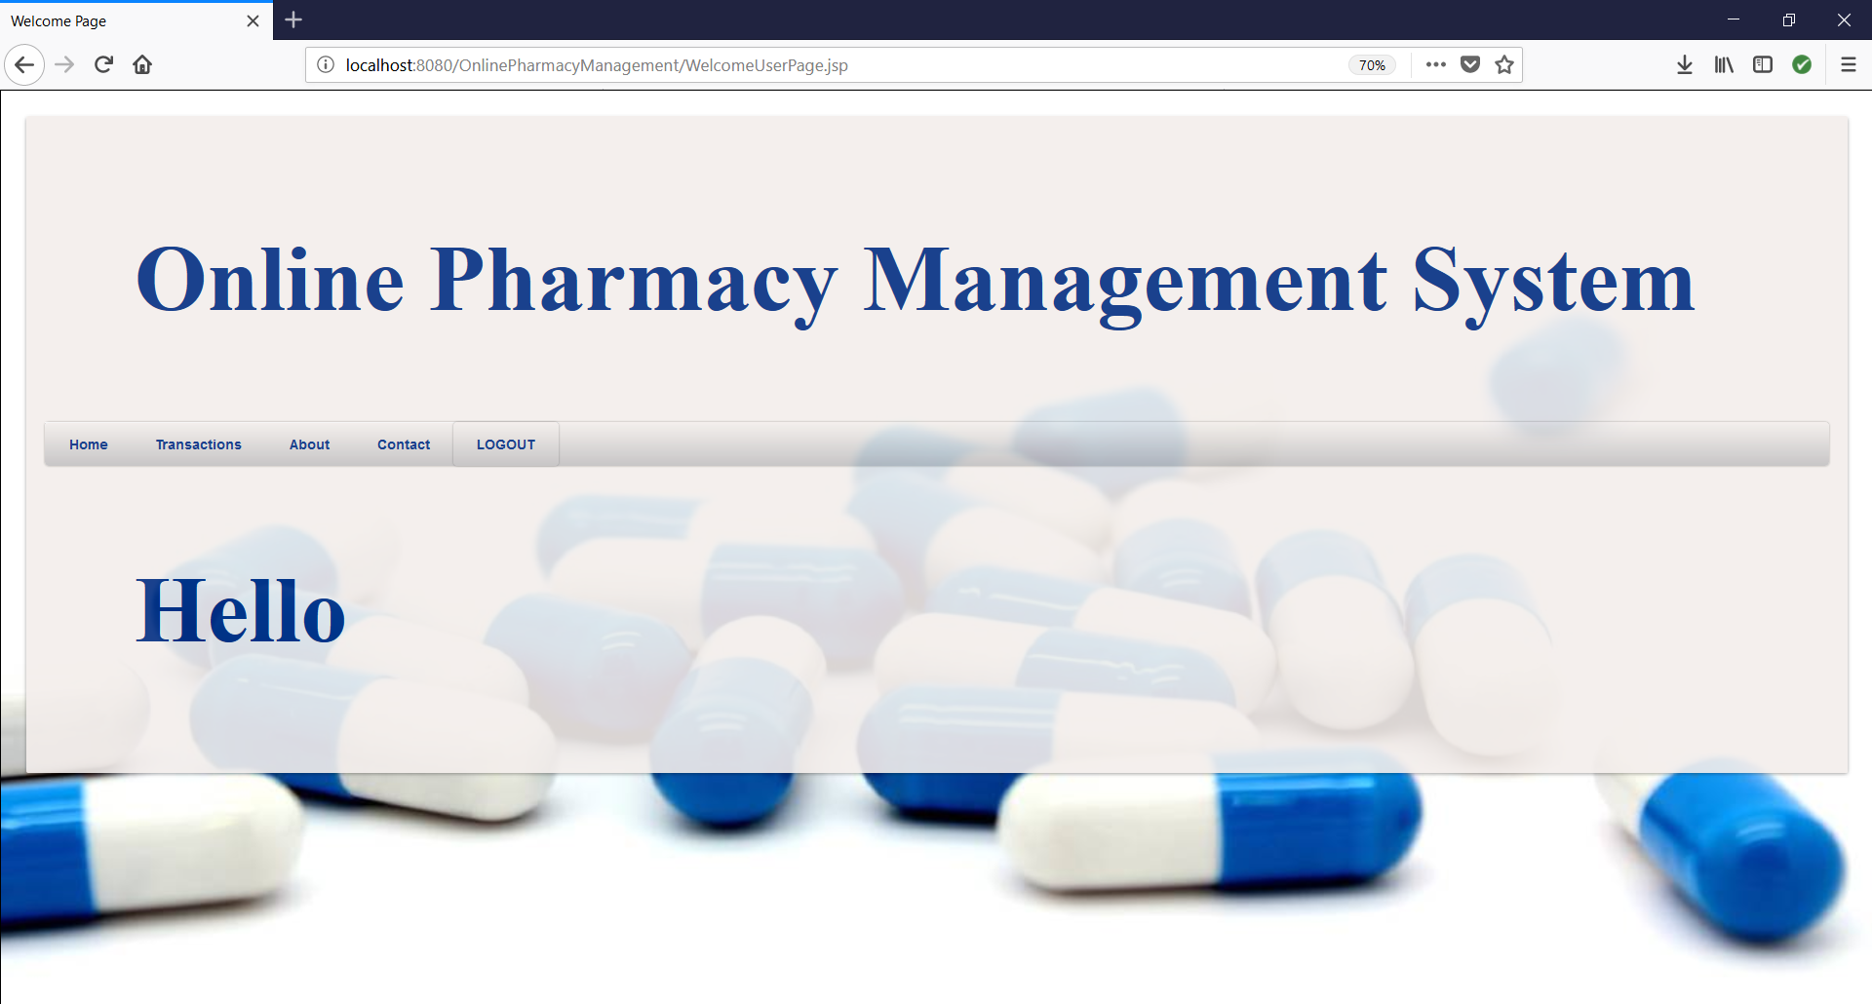

* 1. Admin:



1. Now the admin can do the following:

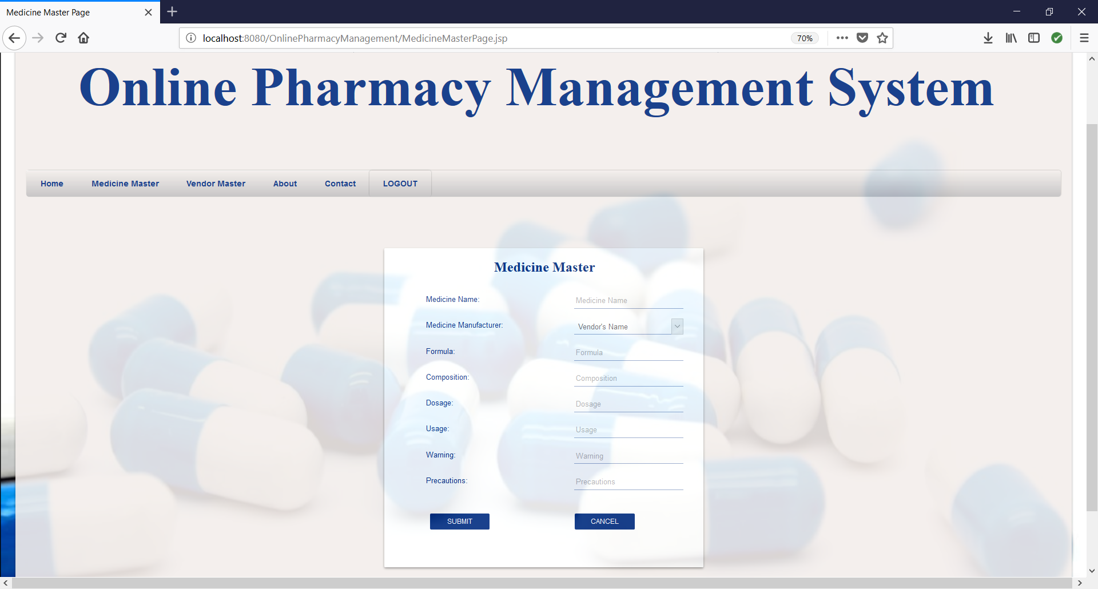

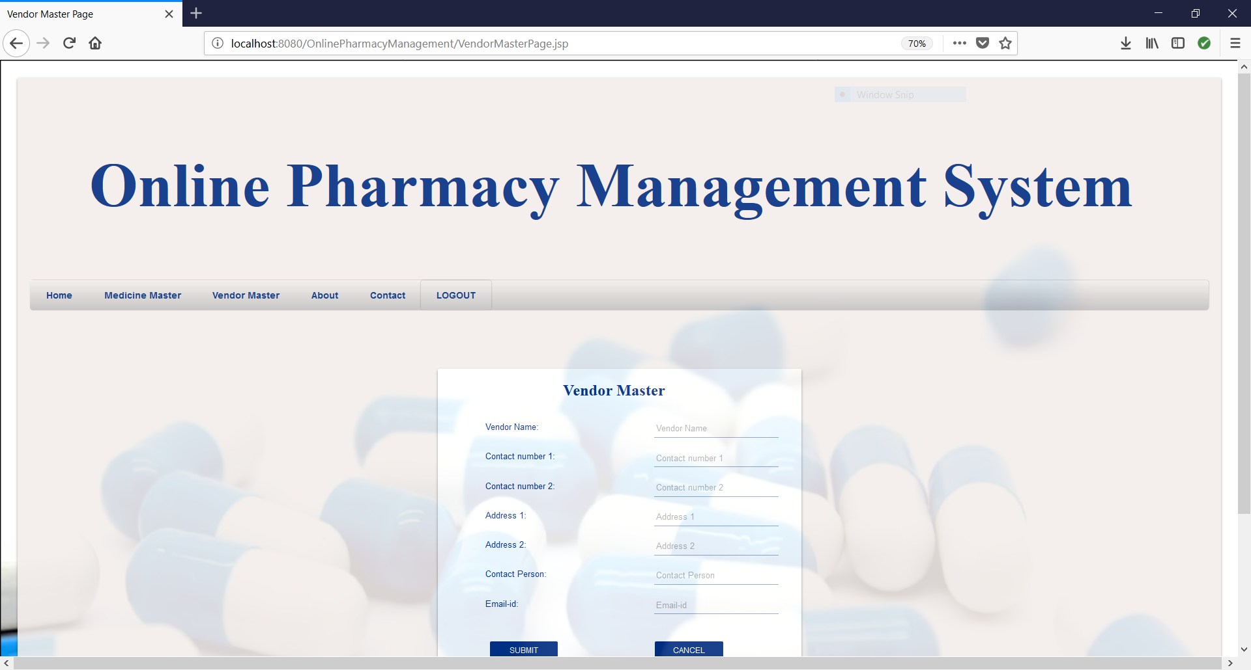

1. And the Sales person can do the following:

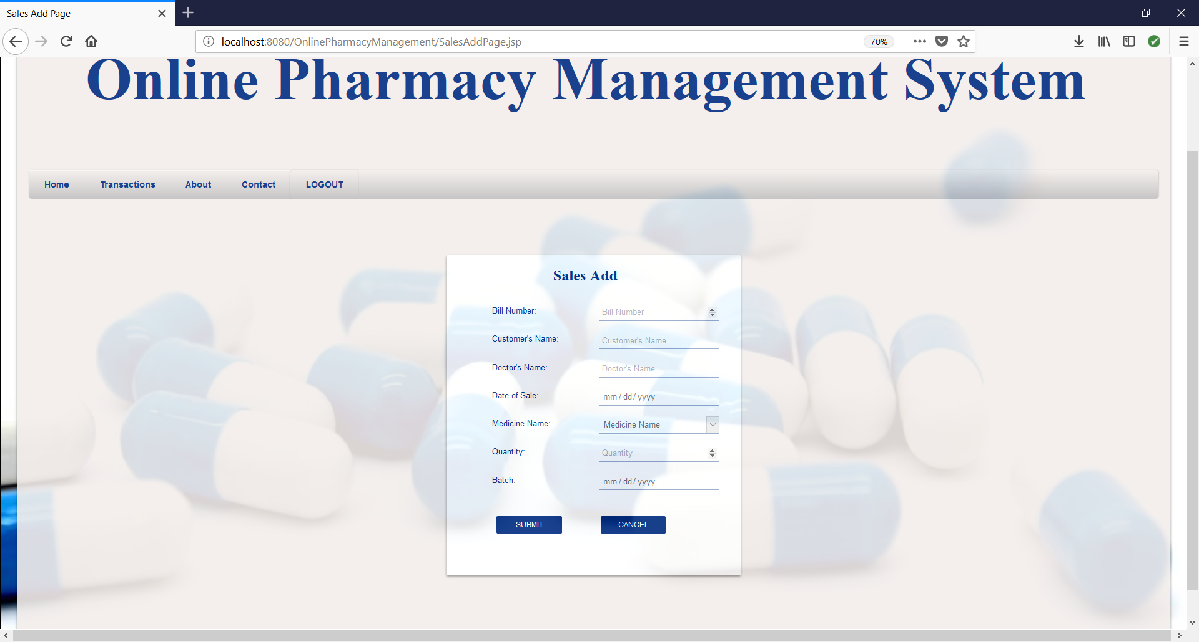

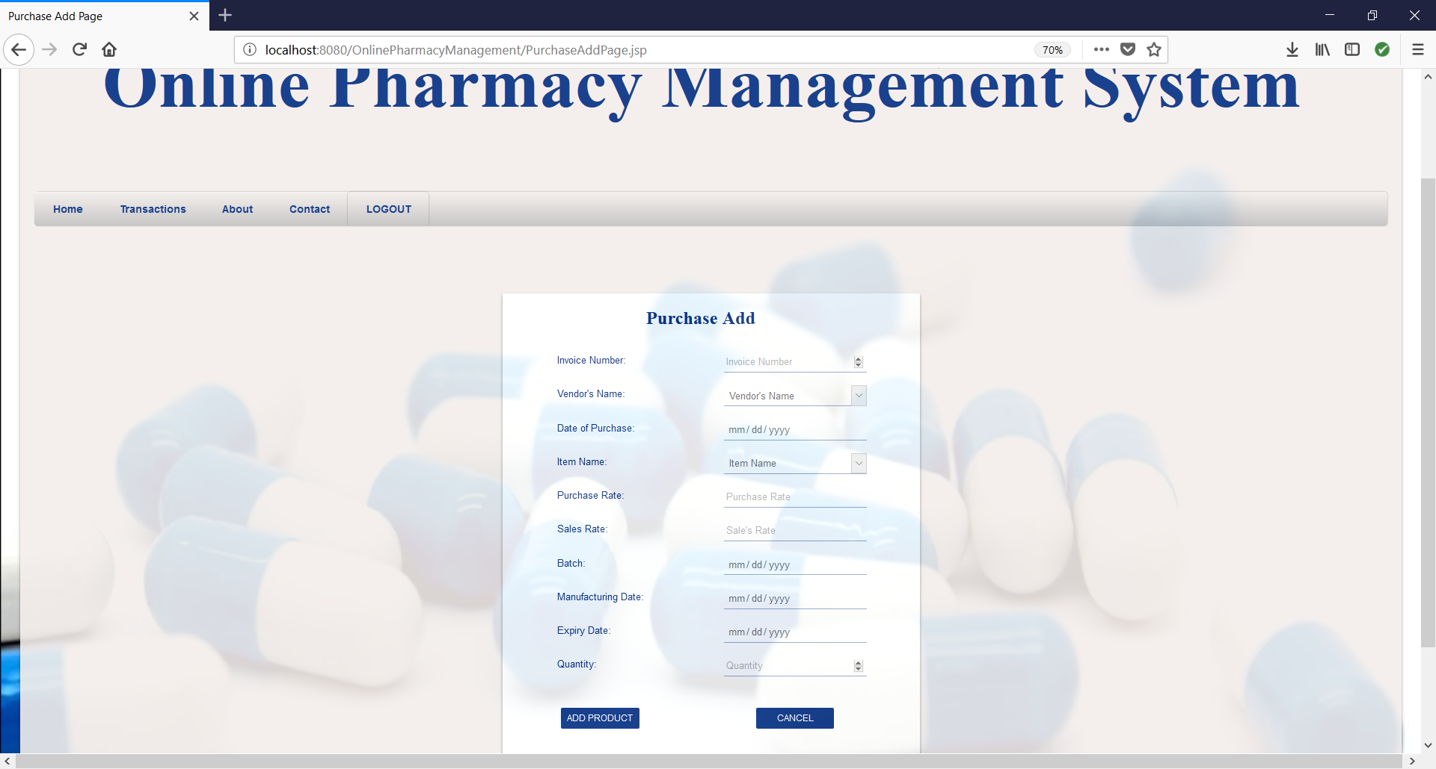

1. Both the users can access the about us page.

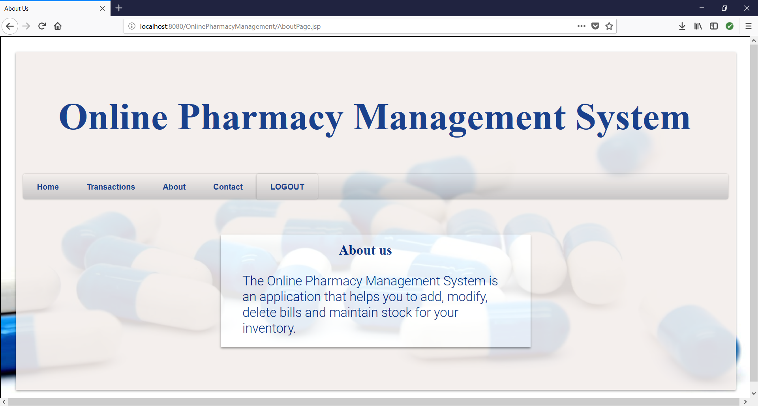

1. Both the users can access the contact us page.

